CS23532-COMPUTER NETWORKS-LAB MANUAL
Practical-5
AIM Experiments on Packet capture tool: Wireshark


Capture
Enter a capture filter . I.
using this filter:
Ethernet
Local Area Connection
Local Area Connection
Local Area Connection* 6
VMware Network Adapter VMnet8
VMware Network Adapter VMnet1
Ethernet 2
&dcap intelface:
US3PcapCMDee
No capture filter
Adzpter for loopback traffic capture US8Pcap1:
Event Tracing for Windows (ETI'V') reac
Time Source Destination Protocol Lengtl Info
- 4.ø29655 172.16.75.93 239.255.255.25ø 179 "-SEARCH * HTTP/I.I
- 4.'329786 172.16.75.93 239.255.255.25ø 179 M-SEARCH * HTTP/I.I
- 4.'334279 172.16.79.251 239.ø.ø.8 11378 39732 * 51721 Len=1ß36
- 4.ø39148 172.16.76.6ø 224.ø.ø.251 119 Standard query response øxøøøø fe8ß : • 6cøe A 172.16.76.6Ø
- 4.'339433 172.16.79.249 239.ø.ø.8 11378 53696 * 51721 Len=1ß36
46ø 4.'339433 few: :d989: 6cøe.• 45em ffm: :fb 139 Standard query response øxøøøø fe8ß : • 6cøe A 172.16.76.6Ø
- 4.1365317 172.16.79.248 239.ø.ø.8 11378 6ø7gø * 51721 Len=1ß36
- 4.'365976 CloudNetwork 79: If: m aroadcast ARP who has 172.16.76.3? Tell 172.16.75.75
- 4.'3751341 172.16.79.251 239.ø.ø.8 11378 47989 * 51721 Len=1ß36
- 4.'378653 fe8ß: : cc8d : ce94: 74ßm ffm: :fb 139 Standard query response øxøøøø fe8ß: : cc8d . A 172.16.76.144
- 4.'378653 172.16.76.144 224.ø.ø.251 119 Standard query response øxøøøø few: : cc8d • . : 74øc:8676 A 172.16.76.144
- 4.'378984 aroadcast ARP who has 172.16.76.6? Tell 172.16.76.144
- 4. e79358 fe8ß: : cc8d : ce94: 74øm ffm: : I: ff4b.•dc37 lcmpv6 86 Neighbor Solicitation for fe8ß: : 3ß5e:847a: 194b:dc37 f rom ea:55:ac:41:ed:ø3
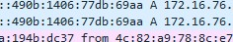
- 4.'3811132 172.16.79.249 239.ø.ø.811378 413958 * 51721 Len=1ß36
lcmpv6
172.16.76.gø
172.16.76.gø
- 4. eg37ß6 few: :4gøb: : 77dm ffm: :fb139 Standard query response øxøøøø fe8ß
47ø 4. eg37ß6 172.16.76.gø 224.ø.ø.251119 Standard query response øxøøøø fe8ß 471 4. eg37ß6 few: :4geb: 14136: 77dm ffm: : I: ff4b.•dc3786 Neighbor Solicitation for few: : 3ß5e:847a: 194b:dc37 from
- 4. ø937ø6 CloudNetwork 78: 8cBroadcast 6ø who has 172.16.76.6? Tell 172.16.76.gø
- Clcudnetxc-k 79: 22Sr-cadcast
- 4.04565 fe8ø: : 7557: 683d.• 23dm ffø2: :fb139 Standard query response øxøøøø
- 4.1394565 172.16.76.112 224.ø.ø.251119 Standard query response exøøøø
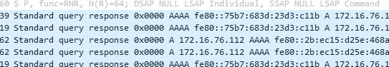
- 4. eg47ø1 172.16.76.112 224.ø.ø.251262 Standard query response TXT 477 4. eg47ø1 172.16.76.112 224.ø.ø.251262 Standard query response TXT
172.16.76.112
172.16.76.112
172.16.76.112
478 4.ø9481ø 172.16.76.112 224.ø.ø.251119 Standard query response øxøøøø
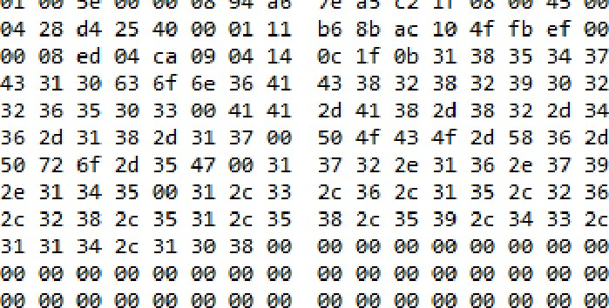
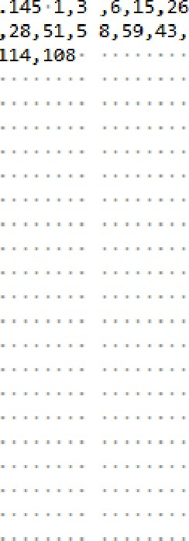
34 37 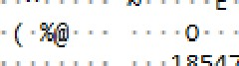
18547
32 ClØcan6A c8282ga2
2d 34-AB-82-4
36 2d 6-18-17 • POCO-X837 39 Pro-56 1 72.16.79
- 38
- 2c
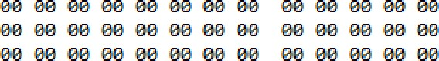
øa øa øa øa øa øø øa øa øa øa øa øa øa øa øø øa øa øa øa øa øa
øa
øa øa øø øa øa øa øa øa øa øa øa øa øa øa øa øø øa øa øa øa øa øa øa øa øø øa øa øa øa øø øe øø øø øø øe øø øø øø øø øz øø øø øe øe øø øa øa
øa øø øa øa øa øa øa øa øø øa øa øa øa øa øa øø øa øa øa øa øa øa øa øa øa øa øa øa øø øa øa øa øa øa øa øa øa øø øa øa øa øa øa øa
øa
øa øa øø øa øa øa øa øa øa øa øa øa øa øa øa øø øa øa øa øa øa øa øa øa øø øa øa øa øa øø øe øø øø øø øe øø øø øø øø øz øø øø øe øe øø øa øa
øa øø øa øa øa øa øa øa øø øa øa øa øa øa øa øø øa øa øa øa øa øa øa øa øa øa

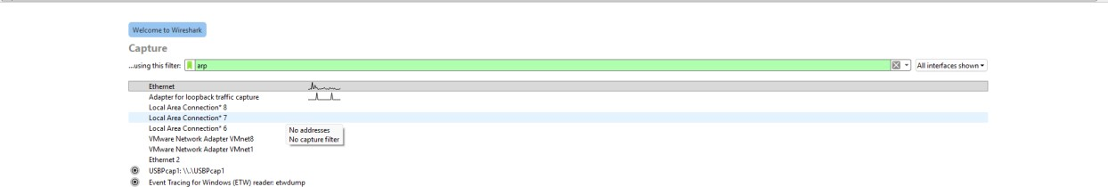
Learn

